
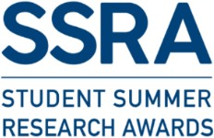
SSRA ETHICS DECLARATION FORM
Submit this completed form on Brightspace no later than 2 June 2026, before your project begins. Ensure all sections are completed clearly and upload this page only.
Name:
Student No:
Project Title:
Supervisor:
- Does your research involve the use of
- human subjects, human data, human tissues, primary cells isolated from humans
AND/OR
- animals, animal tissue?
YES |  |  |  |  | No
- Does your project require ethics approval?
YES |  |  |  |  | No
2.a.) If YES, please provide an UTMREC-SM (or AREC) reference number:
2.b.) If NO, please provide justification:
- Have you completed the Insurance Self-Assessment Checklist and has your Supervisor signed it?
YES |  |  | No |  |  | N/A
Project Supervisor Signature:
Print Name:
Student Signature:
Print Name:
Date:

